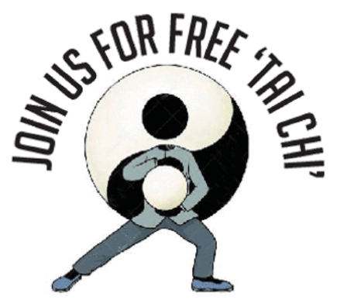
Welcome
to
FreeTaiChiSydney

Tai Chi is a very gentle, low impact form of exercise, with many health benefits. It is suitable for most ages and abilities. However, we need to make sure this form of exercise is right for you.
The instructors are not medically trained so we need your help to ensure this class will be of benefit to you. If you have any concerns about the suitability of this activity, please consult your doctor or physio before joining these classes.
Please complete the questionnaire below and return it to us. The questions about your medical and physical issues just help us to help you get the most out of the classes. The information is confidential and will not be shared or used for any other purposes.

Location  (Circle one) | Centennial Park or Potts Point  Please ensure you choose a preferred location
Name
Age or year of birth
Mobile
Email
Emergency contact | Name: Number:
Medical issues  Eg Diabetes, Parkinson’s  (Circle or provide details) | No medical issues
Physical Issues  Eg pain, balance issues, joint issues hip, ankle, shoulder.  (Circle or provide details) | No physical issues
How did you hear about these classes?
Please email your registration form to the email address below.

If you have any issues, concerns or questions please contact us in person or by email or text.
Looking forward to introducing you to the health benefits of tai chi and sharing the journey.
Mandy and Maggie

M. Mandy.: M: 0439 936 483 Maggie. M: 0404 429 005 E: freetaichisydney@gmail.com

